**Chapter 41 - MY NIECE, HAL & JEAN’S DAUGHTER, CINDI PORTER**

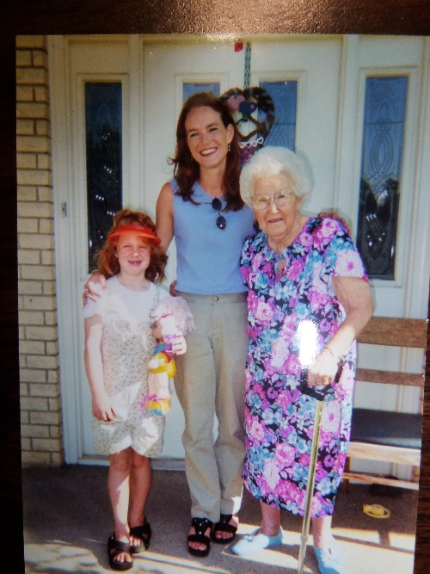 (This picture if of my mother, Mildred Hope Porter, her granddaughter, Cindy Porter, and Cindy’s daughter, Samantha “Sammy”. Cindy was a beautiful and smart girl, but she got on drugs, as a teenager, and they ruined her life.)

Ken and I were on our way to Heber City, just going up Weber Canyon when we received a phone call. It was from the Police Chief at Clinton City. He asked if I was Mae Browning and if I knew a Cindi Porter. When I responded that she was my niece, he said I was to call a Sharon at Boulder Colorado and gave me the number. I tried to question him as to what it was about and finally he said Sharon was from the coroner’s office in Boulder. At that I started to cry and he said he hated to be the one to tell me and that I should call her right away. As soon as I got some control of myself, I did. Sharon was very kind and told me they had been trying to reach Cindi’s next of kin since Friday. Cindi took her life on Thursday afternoon. They found a recent call to Aunt Mae on her phone, but the number didn’t have the prefix, so they didn’t know where Aunt Mae was. They finally found out that Cindi’s parents were both deceased and were buried in Utah, so they called the Utah prefixes and found me. She said they found some credit cards in the apartment and took them so they wouldn’t be found by others and possibly used. When I asked her what we should do, she said to take what time we needed, but then get a trusted funeral home and the funeral home could make the arrangements for Cindi’s body to be sent here to Utah.

I asked Sharon if Cindi’s daughter, Samantha, had been notified or her foster parents. She said “Yes, Cindi’s caseworker had taken care of that”, but said that the caseworker wouldn’t give her their telephone number or any information, so that was another reason why it was so hard to reach any of us. Georgia called Dugans and left a message for them to call ---------

**CINDI’S BISHOP**

When I mentioned to Terry about wanting to get a hold of Cindi’s Bishop, Terry said he would get on the internet and find him and have him call me. Bishop Michael Rayback called about 4 pm of Jan. 9th, the day we found out about Cindi’s death. I could tell from his voice what a caring and loving Bishop Cindi had. As I talked with him, I felt such peace and joy knowing that members of his ward as well as himself loved Cindi and took good care of her. He said he called her as much as 3 times a week. He said that when he called and couldn’t even reach the voice message, he knew that message center was full and that probably she was using again, so he would go check on her and work with her to get her back on track again. He said he felt Cindi had mental illness and that the mental illness is what brought on the drugs – not the other way around. He said he felt it was the same as her father had. I shared with him about Hal’s insomnia and getting on sleeping pills in the service and getting addicted and how frustrating it was for Jean and also for his brothers who took him hiking to get the pills out of his system. I shared with him Hal’s good qualities. He said Cindi had real depression problems as well as the drugs and other health problems because of the drugs and she had been going downhill for some time and he was worried about how he and the ward could take care of her as she was getting worse and worse. But they loved her and wanted too.

The friend, who had been staying with her, found her and called the Bishop. The Bishop called the missionaries who had been teaching her and asked if they could go over. They did and found the police there. The police wouldn’t tell them anything or let them look at anything until Cindi’s next of kin was notified.

The friend was a recent employer of Cindi’s. He had a marketing business and Cindi was working for him by phone and internet. He and his wife separated and he had no place to go, so Cindi invited him to stay with her. He assured me that there was nothing morally wrong going on between them. He was in contact with this man too, and the man had moved out prior to Cindi’s suicide.

When the Bishop notified the ward leaders and it spread from there, everyone was heard saying “Oh, if I had just called her again, or gone to see her, or been there for her, maybe it wouldn’t have happened.” He said I’m sure you are all saying and thinking the same thing, but I don’t think any of us could have stopped it – the mental illness had taken over.” He said “When I told her visiting teacher, she just cried and cried and said “How can I take care of my two children today, I am so distraught by this as I loved Cindi dearly.” He counseled her to pray to the Lord and he would comfort her. He said she bore her a sweet testimony on Sunday and said how as she prayed the Lord spoke to her and said “Cindi is ok, don’t grieve for her, I love her and am taking care of her.” She said that brought such peace and joy to her soul.”

Bishop Rayback said that he had been paying Cindi’s rent for the past two years from ward welfare funds. They had just paid it again for this month last week. He said that Cindi was very good with money and very careful. If ever she went overdrawn or asked him for small loans, he knew she was using drugs again and he could meet and council with her. He said Cindi would get jobs, but couldn’t keep them long the past few years because of the drugs, her health and the depression. She told him: “No one knows how hard my depression is unless they go through it themselves”. He told her he knew that was true.

Bishop Rayback said that Cindi had wrecked her car by running into a curb and blowing out the tire. Bishop said he knew she was using drugs again and that was the cause of the accident. Her home teacher had come to get her and tow the car to a garage. Upon checking the car, it was found that the transmission was about gone and it would cost about $1,500.00 to $2,000. to be fixed. Cindi had told the Bishop that it wouldn’t help to fix the tire, but that she didn’t know what she would do now without a car. (I’m sure that added to her depression). She had told the Bishop about how her uncle gave her the car, and she also told him about all of us – her Porter family in Utah and the love she had for us, and the wonderful time she had when she came to Utah.

Bishop Rayback said that Cindi came to church on Christmas Day with her visiting teacher and she looked so beautiful. He told her “Cindi, I am so glad to see you, this is where you belong.” And she said “Yes Bishop, I know that.”

I mentioned to Bishop Rayback that we had talked with a couple of funeral homes and that the one said it could cost 8 or 9 thousand dollars by the time we pay the coroner in Boulder, had her body flown over, paid for the services of the funeral home and the casket, vault, burial plot and opening and closing of grave. Mark at Walker’s in Morgan suggested we cremate her body and get permission from the cemetery to lay the ashes in either her father or mother’s grave. It would only be $1,500. to $2,000. Bishop Rayback said “yes”, I would agree, I think that it what Cindi would want. She wouldn’t want you to spend a lot on her, especially when she knows all of you will have to pay it and none of you are wealthy. He said his father wanted to be cremated, and so they honored his wishes, since his mother and father were divorced and there was no one, other than him and his father’s sister to pay for it. He said he ended up paying the $2,000. He said the ashes were put in an urn and later when it was convenient to have a gravesite service, they did. He said there is no hurry when a cremation takes place. He said the church doesn’t frown on it either, they feel it is up to the family to decide.

Bishop Rayback said Cindi really struggled with her father’s suicide, and that the year she became the age he was when he died (36) she had a really hard time and they talked about it. She showed him a treasured birthday card she had received from her father when she was a child and it said “To the most beautiful little girl in the world.” It made her depressed, but he told her “No, Cindi, you should realize from that how much your father loved you, and it should make you happy, not sad.

Bishop Rayback said since the ward members all loved her, they would like to have a service where the members could say “goodbye” to her. I told him that would be wonderful. He said the members loved her and knew that she loved them and appreciated all they did for her. He said Cindi had wonderful home teachers and visiting teachers, plus many, many other friends in the ward and also many friends not in the ward.

Bishop Rayback asked what they could do and I said if they could take care of the apartment – give the furniture and clothes to needy families and close the apartment. He said Cindi had some personal belongings and if someone came to pick them up, they could get the urn with the ashes at that time, if that is what we decided to do.

Bishop Rayback gave me his phone number and e-mail address and I gave him mine. He said we would keep in touch until it is all settled. He said if there is anything else he or his ward could do, they would be happy to do it